Slow Cooker Chicken & Vegetable Casserole.
Prep Time 10 minutes
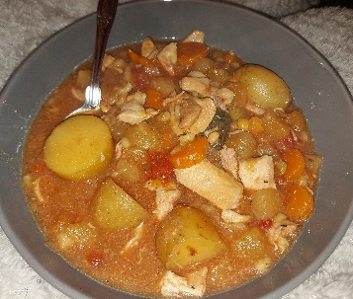 Cooking Time 6 hours on slow.
Serves 3 Adults + 3 Children (or 2+2 with leftovers)
Ingredients
Slow Cooker liner(optional)
1kg boned & skinned Chicken Thigh.
1kg bag Frozen casserole mix (from any store is fine).
1tin chopped tomatoes.
100g soup/broth mix (lentils, split peas, barley) optional. Soaked and par boiled as per packet directions.
Chicken stock.
Pt water.
Herbs I used mixed herbs, garlic granules, bouquet garni.
- Chop chicken thigh meat into even size pieces do a decent size so it does not breakdown during cooking.
- Line slow cooker with a bag.
- Layer diced chicken & frozen vegetables (it will look full but as it cooks/defrosts will reduce in size
- Add tin tomatoes and herbs of your choice.
- Melt the stock cube in the boiling water and pour over the mix and stir.
- Weigh out the broth mix if you decide to use them, you will need to soak overnight, or part boil then add to casserole mix to finish cooking.
- Stir all ingredients together cover with lid and set to cook stirring occasionally so not to break up meat and veg too much.
- Once cooked adjust season serve out, as the addition of pulses/broth should thicken, if this is not to your likeness then you can add a thickening agent.
- If there are leftovers this can be frozen or made into a chicken & vegetable pie for another meal.
- Please note If using for small children or babies do not forget to only add stock after taking out their portion, as salt is not recommended. Then either mash or break down chicken so then can eat safely.

